**UNIVERSITY OF SUNDERLAND** 

**ASSIGNMENT**

|  |  |  |  |
| --- | --- | --- | --- |
| **Student ID :219305860** | | **Student Name/ Names of all group members:**  **Akash Dhital** | |
| **Programme: BSC computer system engineering** | | **Module Code and Name:** CET313 Artificial Intelligence | |
| **Module Leader/ Module Tutor:** Himalaya Kashapati | | **Due Date: 2022/4/8 Hand in Date: 2022/4/8** | |
| **Assessment Title:** Intelligent Prototype Development | | | |
| **Learning Outcomes Assessed: (number *as appropriate*)** | | | |
| |  |  | | --- | --- | |  | **Mark** | | **Areas for Commendation** |  | | **Areas for Improvement** |  | | **General Comments** |  | | | | |
| **Assessor Signature:** | **Overall mark** | | **Moderator Signature** |

**……………………………………………………………………………………….**

**PRINT Student Name**: Akash Dhital Faculty Stamp *(date/time)*

**Student Signature** : ______________________________________________

**Module Code and Name**:CET313 Artificial Intelligence

**Name of Module Tutor** : Himalaya Kashapati

**Introduction**

Pregnancy-related health issues are becoming a worldwide problem. The death of the fetus is more common in undeveloped and impoverished nations as a consequence of these issues. There has been tremendous improvement in illness diagnosis, treatment, and prognosis thanks to the emergence of Machine Learning (ML) algorithms in healthcare. Predicting the health of the fetus using cardiotocographic (CTG) data using machine learning algorithms is a new frontier in prenatal medicine. Predicting a fetus' health using algorithms like Support Vector Machines (SVM), Random Forests (RF), Multilayer Perceptron (MLP) and K-Nearest Neighbors (KNN) is explored in this study (K-NN). As a result of this, regression and correlation analyses showed that the qualities had an impact on fetal health. Based on the findings of the algorithms, RF outperforms its competitors in terms of precision, precision, and accuracy the ability to remember and perform an F1 test, and the availability of resources. To further improve promising outcomes, feature engineering may be used to CTG data.

To better understand the health of human fetuses, this article discusses the methods used by a group of researchers. It is the goal of the suggested prototype to use Classification Machine Learning (ML) to detect and classify fetal health in the mother, which would assist lower the mortality rate globally. Hence, machine learning is an efficient and effective method for treating these patients in a better manner and cutting down on the time and effort required by medical professionals. In order to predict a possible fetal health concern, machine learning models just need some associated property of the patient, which may be determined by basic tests like Cardiotocograms, which are relatively cheap cost and have a low complexity. When applied to high-dimensional data, four ML approaches, such as the Neural Network, the K-Nearest Neighbor (k-NN) Classifier, and the SVM, outperform all others in providing reliable diagnostic indexes (Akhtar F, 2019).

* 1. **Mission Statement:**

Using Classification Supervised Machine Learning (ML), this proposed prototype aims to predict the prenatal health state of human beings and thereby lower the mortality rate globally. A patient's fetal health issues will be classified based on the patterns in the dataset. Classification models will be used to undertake experiments to explore the dataset's relationships and trends. Fetal health diagnosis will be determined by looking at noticeable characteristics.

* 1. **Overview of e-Portfolio:**

It was a delight to go beyond what we learned in lesson. We were able to work together as a group to develop and build python programs thanks to the additional exercises and study subjects. We learned more about AI via group discussions and research, such as kinds of machine learning, types of clustering algorithms, and search algorithms. I preferred using Google Colab instead of jupyter for building programs since it was easier for me to use. Because I was using Google Colab in my python foundation class, I had a better understanding of how to utilize it. E-portfolio tasks were developed using Google Colab for all the weekly tasks. Here is the link of my e-Porfolio link:- <https://canvas.sunderland.ac.uk/eportfolios/7761?verifier=8FXGyL91lwqh2C1xvimV11RbJ2Ygj6Zh4uzvTpHw>

**Section 1: Prototype Identification and Planning**

**Literature Review on Prototype Identification**

Some related work has been done in this following topic. The models Bayesian and lightbgm were both successful, and the prediction was improved by a minor amount of performance (Andrew Maranho Venture Dadario, 2021). Using CTG data, an ANFIS proved its effectiveness by accurately predicting normal and pathological states with 97.2% and 96.6% accuracy, respectively (Ocak, 2013). It says that while comparing the classifiers, random forest and XGBoost perform well, however the dataset used is unbalanced since some modified version is needed to produce the best result in terms of accuracy. CTG data has been shown to be useful in identifying anomalies in the dataset that was utilized. On the machine learning models utilized, the decision support system concentrates its visual analysis (Piri, 2019).

After a 10-fold cross validation, the ensemble model has an accuracy of 99.02 percent based on the machine learning. As a result, the CTG data may be classified as either normal or abnormal using this method. As a result of testing the data using a 10-fold cross validation, the best results for both the Artificial Neural Network(ANN) and the Logistic model are 98.47 for the former and 98.74 for the latter, with the Logistic model outperforming the former by a minuscule amount of precision (ANN) (Ocak, 2013).

AI and digital technologies, machine learning, and data analysis for fetal health classification have all been made possible thanks to global technology growth. Healthcare practitioners are increasingly relying on artificial intelligence (AI) to assist them care for patients and handle administrative tasks. Artificial intelligence (AI) has aided healthcare providers by assisting with administrative tasks as well as patient care. Machine learning is becoming the most used method of data analysis. Artificial intelligence (AI) is being used to construct the core of the system. The use of Machine Learning in the Predictive therapeutic techniques based on a framework for understanding care and well-being The use of fetal health classification systems such as machine learning. For a female individual, health issues are extremely common during the course of her pregnancy. This will aid in the advancement of disease diagnosis, treatment, and prognostication classification and structure through the use of machine learning techniques (Akbulut, n.d.). The categorization of fetal illness is included in the report in order to avoid the death of the mother and child during pregnancy. The reduction of mother and child mortality rates is one of the most pressing issues facing those working to improve healthcare. The research offers analysis via the deployment of several prediction models based on the data supplied by the dataset in order to identify the fetal health concerns that were discovered (Akbulut, n.d.).

Random Forest, logistic Regression, KNN, and Gradient Boosting are the models used for classification of fetal health where Random Forest is first supervised approach for machine learning built on the decision tree algorithm. This approach combines several classifiers to solve a broad variety of complicated issues (Siddiqui, 2020). The dataset evaluated 2126 records of characteristics collected from Cardiotocogram tests that may be classed as Normal, Suspect, or Pathological. It is possible to develop predictive models using gradient boosting and decision trees because the fundamental method is improved by regularization techniques, which are implemented in the algorithm. A further approach, K-Nearest Neighbour, is utilized for calculating the distances between all of the specified locations that are in close vicinity to an unknown dataset. This Fetal health categorization by machine learning algorithms 6 aids in the filtering of data by identifying the data with the smallest distances associated with it. The last model discussed is logistic regression, which is yet another classification procedure that is assigned to the observation of a collection of discrete classes in a certain time period. It assists in the transformation of its output via the application of the logistic sigmoid function, which results in the return of a probabilistic value.

According to the results of a recent rush in the deployment of four machine-learning techniques, namely the NN and k-NN Classifiers, the SVM, and the Decision Tree, which were evaluated on high-dimensional data, the classifier SVM dominates all other techniques in terms of providing accurate diagnostic indices (Akhtar F, 2019). All the Classifiers work well and they use 30 ranking characteristics to establish common risk variables in the prediction model. If you are utilizing machine learning algorithms, feature extraction and selection are two of the most often utilized approaches for selecting the most optimal features for prediction in the model. This would even assist in determining which features should be given the highest priority (Lu C, 2014). The performance of the method may be evaluated using a variety of measures, including Accuracy, Specificity, Precision, and Recall. Overview of utilizing machine learning for fetal alterations assessment, including improving the picture obtained and the efficiency of identifying cardiac anomalies is provided. The procedure of using CTG signals and their principles is detailed in detail with regard to analyzing historical data, and the results are shown. Picture data has been collected in conjunction with the installation of CNN architecture in Deep Learning (DL), with the goal of validating the data from CTG signals against the data collected during image capture (Akhtar F, 2019).

**Section 1.2 Reflection on the Prototype Identification**

The research uses machine learning to classify fetal health by analyzing the supplied information and developing several models. The report classifies fetal health for avoidance of problems during pregnancy The fetal health key elements include used to plan and execute analyses. Cardiotocograms are simple. Examining concerns to identify them as normal, suspicious, or abnormal. It aids in learning about fetal heart rate, problems, and movement’s bladder contractions the data come from a dataset analyzing cardiotocogram data using several models for analyzing data the models used to classify fetal health are Random SVM, Gradient Boosting, KNN, and Logistic Regression.

The many algorithm methods listed above are helpful in the medical field, for example, classification of fetal health using a random forest classification approach. Because it supports classification, prediction, and regression, the technique is very versatile in its use. I liked that classification provided numerous decision trees before providing output, which I thought was a good approach. After the procedure, the process ensures that the results are more precise. Working with the Random Forest was an incredible learning experience for me. By doing more study on this algorithm, I realized that it may be used to a wide range of large real-world challenges such as urban planning and numerous support systems that need visual semantic judgments. Despite this, I noticed that the method is quite sluggish in processing data due to the large number of trees in the dataset. By using the Decision Tree approach, I was able to identify the issue of overfitting as well.

**Section 2: Development**

***Developed code and planning documents for prototype***

In this project, i employ three pre-processing scenarios, where the first scenario is pre-processing by eliminating outliers and utilizing data that has been adjusted using up sampling approach, but the difference is without removing multicollinearity. In the context of multicollinearity, an independent variable that is strongly correlated with one or more of the other independent variables. Multicollinearity might present issues when we fit the model and understand the results. Because multicollinearity is a common concern, the dataset's variables should be uncorrelated. After that comes pre-processing without eliminating outliers or reducing multicollinearity, followed by balancing data utilizing up sampling methods and finally the third scenario (S3) in which all outliers and multicollinearity are removed and normal data is used. Before the data is divided into 70/30 training/testing ratios, all of these steps are carried out on the data. They are from the Fetal Health stroke dataset, which is used in several studies. Due to a lack of data, the model can only predict to use data from a reliable source As a result, Created from the Fetal dataset. This info uses numerous variables to predict fetal health baseline, accelerations, fetal uterine contractions, minor decelerations, etc. Machine Learning and Data Visualization Filtering is used to choose a subset of train data The characteristics may be observed in fig1.

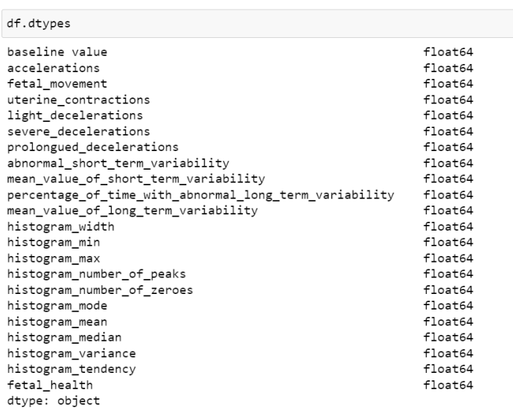

Fig1: Dataset Overview

**B. DATA PREPROCESSING:**

The patterns or things that make up a dataset are called data points. An item's essential properties, such as the mass of a physical object or the time at which an event occurred, are captured by a collection of characteristics. Null values are the first thing to be removed in order to improve the dataset's quality since they might raise questions about the dataset's correctness. In order to gain an overview of the dataset and get a head start on the feature engineering process shown in the figure 2, a brief explanation of the dataset is necessary.

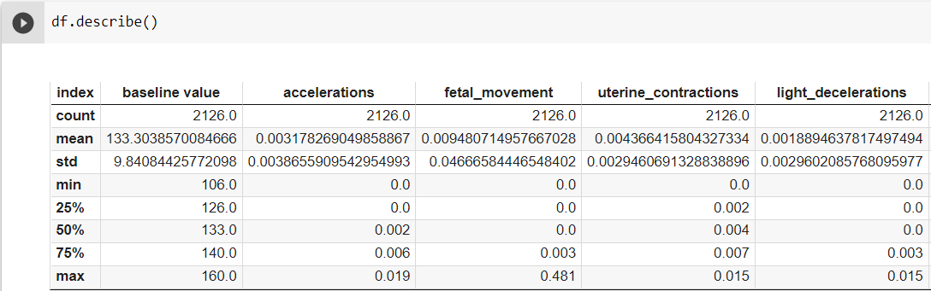

Figure2: Dataset Description

**C. FEATURE ENGINEERING**

Everything from the input to the result is reliant on the feature engineering that is being conducted, thus it is critical. To begin, a slice of pie Figure 3 is a visualization of the chart given. Understand the many fetal health conditions and get familiar with whether or whether it's important. Figure 4 shows us, while gathering the data necessary to construct a correlation matrix significance. In order to determine the, the correlation matrix is used. The relationship between each feature and trait and the database contains all of the other characteristics.

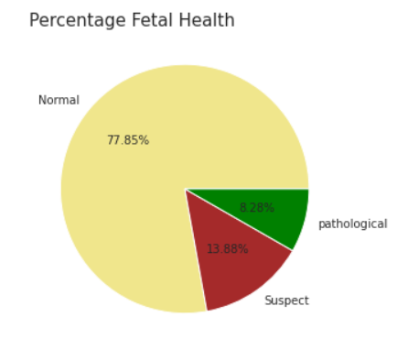

**Figure3: Fetal Health pie chart**

**D.Model Architecture**

**1.Random Forest Classifier**

Samples from diverse data sets are collected and the optimum answer is predicted using the Random Forest Algorithm. Decision Tree-like structure is formed. Additionally, it's more precise than the Decision Tree. However, it is more difficult to forecast and more time consuming to implement.

**2) SUPPORT VECTOR MACHINE**

In the Support Vector Machine technique, data sets are partitioned into support vectors by a Margin and a space known as the Hyperplane is created between them. It's a commonly utilized algorithm with a plethora of real-world applications.

**3) LOGISTIC REGRESSION**

There are just two possible outcomes in a Logistic Regression model. True or False, 1 or 0. For example, Logistic Regression employs one or more Independent Variables to predict a result, making the method quicker and more efficient.

**Used general purpose libraries**:

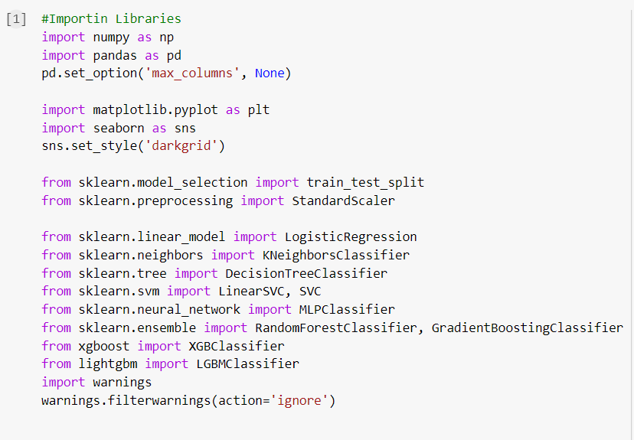

Array management and pre-processing are performed using NumPy, while the Pandas library is used primarily to handle data that has been downloaded in CSV format from the Kaggle repository, as seen in the screenshot. In this case, the matplotlib pyplot module is used for visual graphing, while seaborn is utilized for more complex plotting visualizations.

**Dataset loading:**

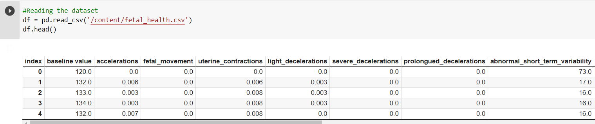

As can be seen in the example above, the read csv() function of Pandas is used to load the dataset in csv format, and as can be seen in the output, a total of 2126 rows are included in a DataFrame with 22 columns. As a result, there are a total of 2126 cases in the data.

**Data types of attributes and missing value exploration:**



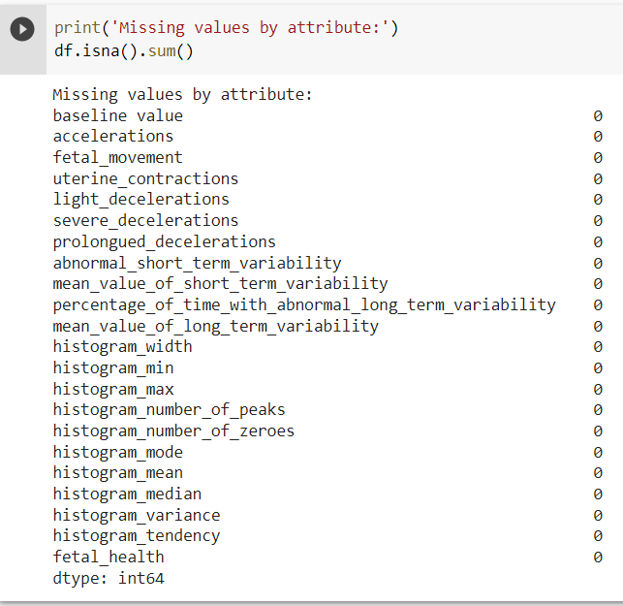

Now, based on the above mentioned outputs, it can be observed that all of the attributes that have been imported into the DataFrame are numeric, including the class variable fetal health, which is shown as an integer. This is due to the fact that class labels are coded with unique numbers, and as a result, the requisite numeric to nominal conversion must be performed. Furthermore, no missing values are found in any of the attributes, and as a result, no filtering or imputation of attributes is necessary.

Numeric encoded classes are converted into nominal classes by matching their names:



In the above output, it is indicated that the conversion of integer to nominal values is accomplished by Pandas' replace function, which is implemented by the replace function.

**Visual of class distribution:**

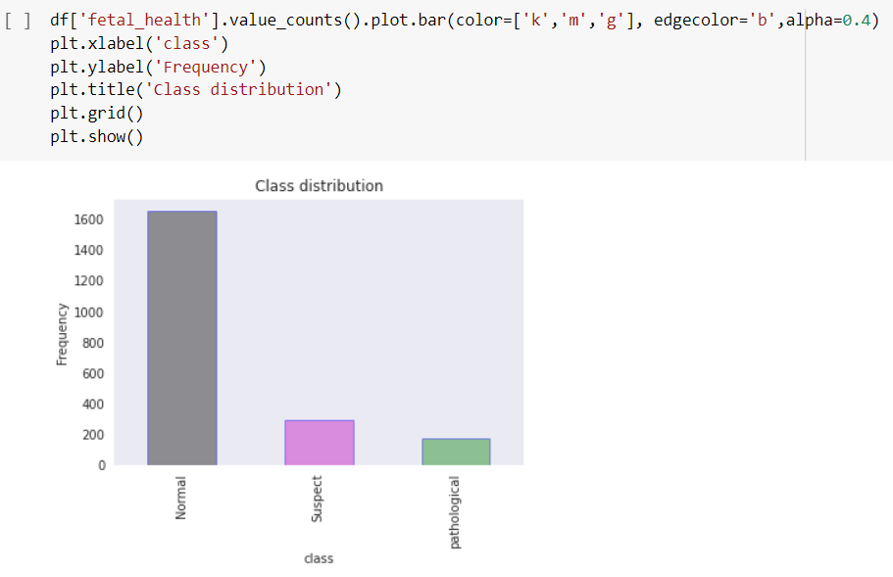

This dataset is clearly unbalanced, as seen by the Pandas bar chart, which depicts the distribution of cases by class (normal vs suspicious versus pathological). There are more than 1600 people in the normal class and less than 200 people in the suspicious and pathological classes.

**Exploring correlation among features:**

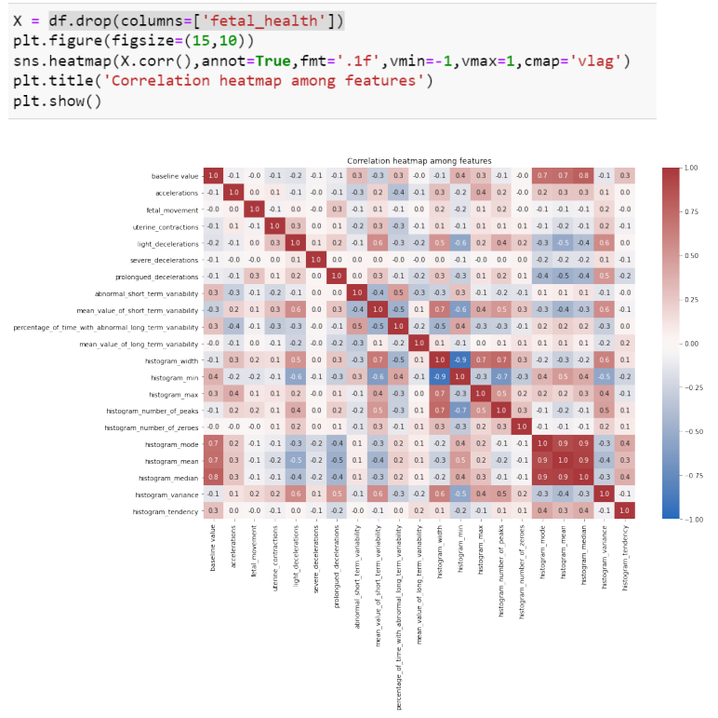

Now, before deploying a machine learning model, it is a good practice to examine the relationship between feature properties in order to choose the most suited model for the situation. The dependency between the features is explored by the correlation heatmap shown above, in which features with a high positive correlation are colored with a high intensity of red, while features with a high negative correlation are colored with a high intensity of blue, and features that are nearly uncorrelated are colored with a color close to white. As can be seen from the table above, the majority of characteristics are almost uncorrelated, with the Pearson correlation coefficient being close to zero; but, between certain characteristics, there is a strong positive and a high negative correlation (Bisong, 2019).

**Train-testing is divided in a 70:30 ratio:**

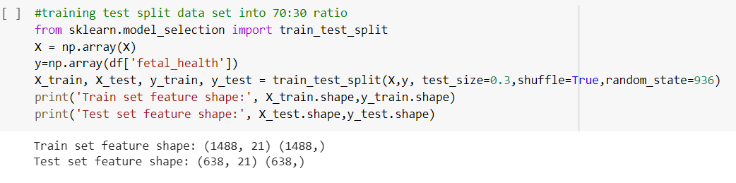

In the following stage, the data and responses are divided into a training and testing set of 70:30, using a random seed of 936, to ensure repeatability of the split. The chosen machine learning models are now random forest, logistic regression, gradient boosting and k-nearest neighbor.

**standardization and RFECV feature selection, the random forest classifier model is fitted and evaluated as follows:**

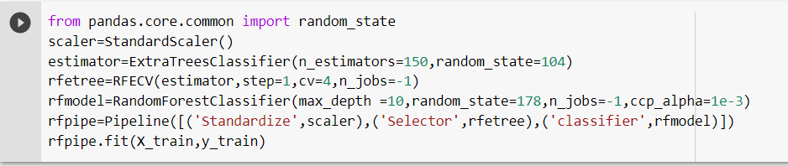

Extra trees classifier estimator performs recursive feature reduction with 4-fold cross validation after standardization of features and before fitting the first model random forest in pipeline. So, until all feature scores above the mean threshold of all feature scores, features are deleted step-by-step based on estimated significance values (Dogru, 2018). The random forest with a maximum tree depth of 10 and a Minimal Cost-Complexity Pruning parameter of 10^-3. These settings are determined after numerous trials to maximize test set performance.

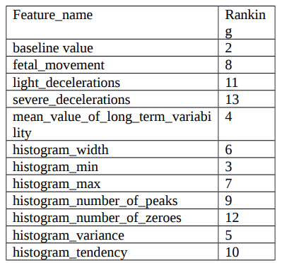

The RFECV chose 9 characteristics for model fitting in pre-processing phases, which are presented and ranked in the table above. The feature severe decelerations has the lowest rank or is deleted first, whereas baseline value has the greatest rank or is removed last.

**Logistic regression classifier model fitting:**

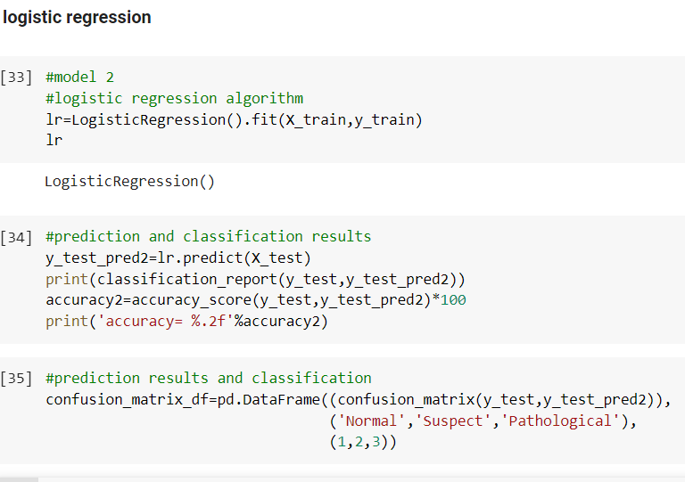

**Random Forest Classifier model fitting:**

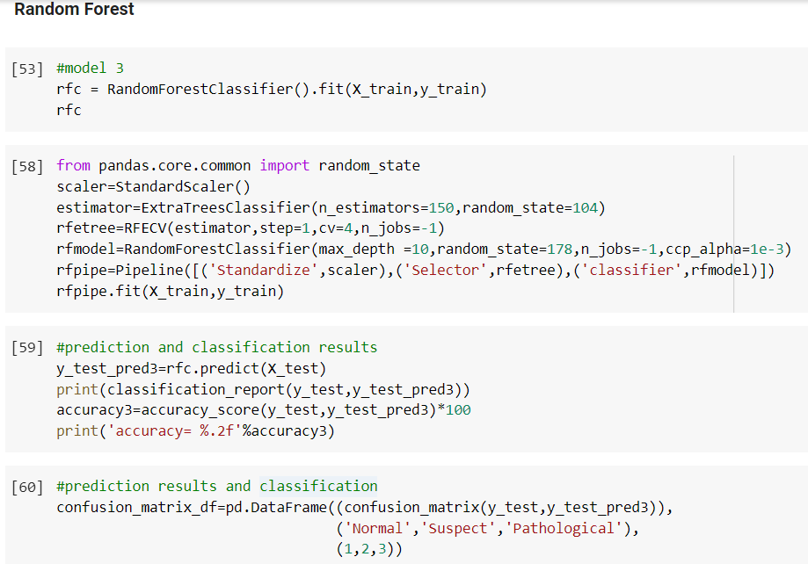

**Section 3: Evaluation**

***Report on the Evaluation***

Currently, in this part, five models that were fitted to the provided pipeline are shown and compared to determine the best model for predicting the fetal health of the child.

In the categorization report, the metrics for assessment defined previously are displayed. Each of the three classes of receiver operating characteristics curves and the overall average place tucked away there. In addition, all of the assessment outcomes shown may be reproduced in a similar fashion. Models that include randomness into the fitting process utilize random states.

**Evaluation results for random forest classifier:**

**Confusion matrix:**

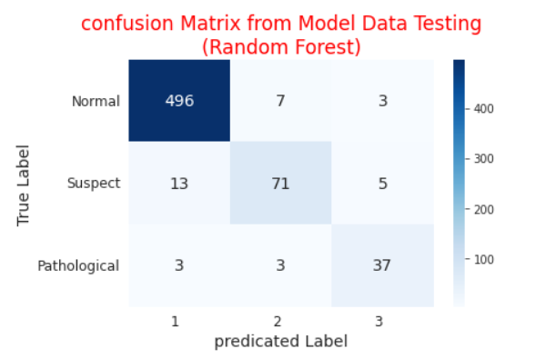

**Classification report in test set:**

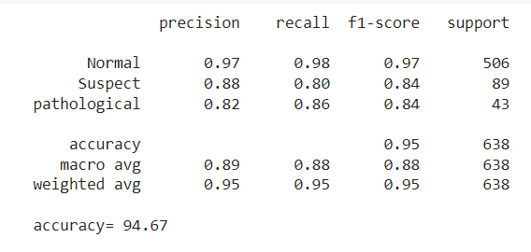

The random forest model has an overall accuracy of 94.67, with accurate identifications of 496, 71, and 37 cases of normal, pathological, and suspicious, respectively. The typical class has superior accuracy, recall, and f1 score than the other classes. As a result of these findings, the model seems to be better at predicting normal than other classes, but it does not appear to be as good as the other classes overall. Classes are assigned varying weightages based on their individual instances, as can be seen by the macro-average scores of the metrics, which are somewhat lower than the weighted average scores.

**Results of logistic regression classification:**

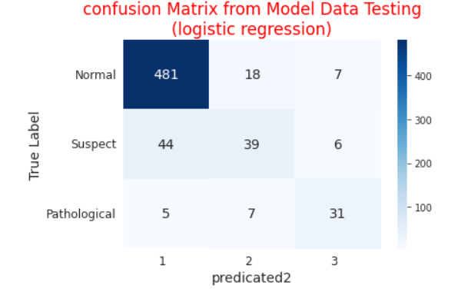

**Test set classification report:**

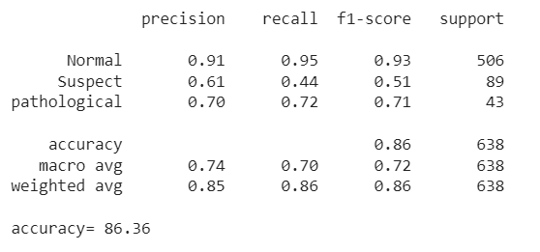

The results of the logistic regression demonstrate that the model has an overall accuracy of 88 percent, with accurate identifications of 481, 39, and 31 cases of normal, pathological, and suspicious, respectively, which may be regarded pretty excellent. The typical class performs much better than the other classes in terms of accuracy, recall, and f1. As a result of these findings, the model seems to be better at predicting normal than other classes, although it is only somewhat better than other models. Classes are assigned varying weights, as seen by the macro average metrics scores, which are much lower than the weighted average metrics ratings.

**Evaluation results for gradient boosting classifier:**

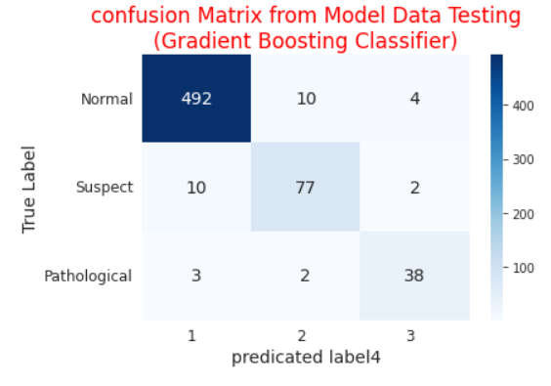

**Classification report in test set:**

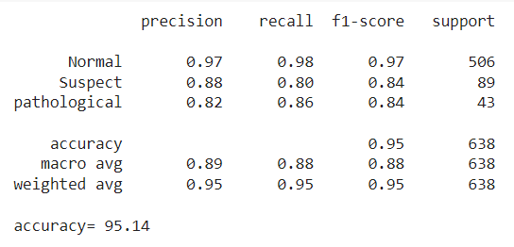

A 95.14 percent overall accuracy rate, with accurate identifications of 492, 77, and 38 examples of normal, pathological and suspicious in the assessment findings for the gradient boosting classifier as given above is regarded an excellent performance. There was a significant difference in accuracy, recall, and f1 score between normal and non-normative groups. As a result of these findings, the model seems to be better at predicting normal than other classes, but it does not appear to be as good as other models. Metrics have a significantly lower macro average score than their weighted average score, which indicates that classes are assigned various weightings depending on their specific occurrences.

**Evaluation results for K nearest neighbor classifier:**

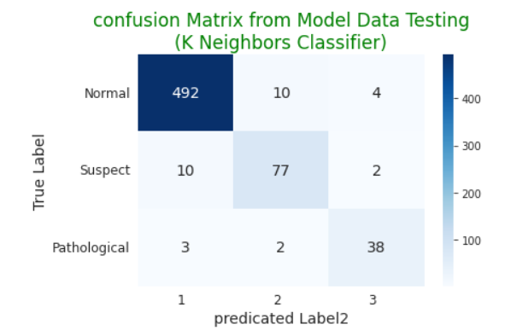

**Classification report in test set:**

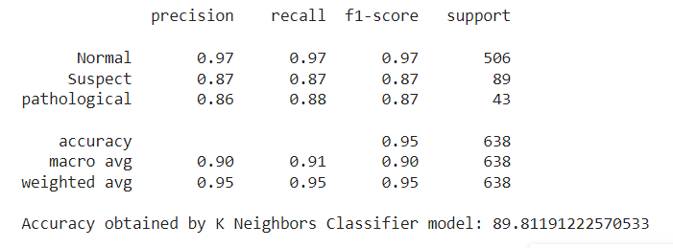

It's easy to observe that the KNN classifier has an overall accuracy of 89 percent, correctly identifying 486 instances of normal, pathological, and questionable data (as shown above), which is an excellent result. The typical class performs much better than the other classes in terms of accuracy, recall, and f1. As a result of this, there seems to be much more of the typical class than there is of any other class. There is also a noticeable difference between the macro average scores of the metrics and the weighted average scores, which indicates that classes are given different weights depending on their specific instances.

**Conclusion:**

Predicting prenatal health issues using machine learning algorithms may be summarized' by looking at the literature review sources offered. We conclude that the planned prototype execution was successful thanks to a variety of ideas and methodologies from various sources. Some of the models used to administer the program were excellent at classifying fetal health, while others were not. In the dataset we utilized, out of the thirteen characteristics investigated, four stood out as very useful for classifying diagnoses as either negative or positive: After modeling and training, the classification system can now distinguish between patients with and without g Cardiotocogram characteristics. Diagnoses may be made that prevent symptoms from worsening in the future. The Random Forest model has the best accuracy of 94%. With its dual ensemble approaches for regression and classification, it was easy to implement. I chose to train the algorithm using the classification route, and the results were fantastic and accurate as a consequence. Random forest algorithm may be utilized as a Blackbox in enterprises, where it can provide predictions for a broad variety of data, as I learned more about it through my investigation.

For the prototype for fetal health prediction using numeric characteristics derived from Cardiotocogram tests, multiple machine learning classifier models were used to construct the prototype. Based on all characteristics, random forest outperforms other models in a limited selection of data called a test set. As the prototype models develop, they are adjusted multiple times until the metrics scores do not increase significantly, and the prototype as a whole does not improve significantly. In most situations, the models' outputs are adequate, and they are chosen based on past research's machine learning theory. Although the models' performances are excellent (especially random forest), they may not be completely optimized because to vast parameter spaces and inability to optimize them all via brute force. Hence, in the future, this study may try to create an intelligent algorithm for optimizing big parameter models, although the performance is not likely to improve considerably. Also, the dataset sample size is small, therefore sampling error might be considerable when predicting huge data with uncertain labels. To boost model validation for bigger datasets, extra children and mothers' Cardiotocogram characteristics may be collected.

# References

Akbulut, A. E. E. a. T., n.d. Fetal health status prediction based on maternal clinical history using machine learning techniques. *Computer methods and programs in biomedicine,* v(163), pp. 87-100.

Akhtar F, L. J. A. M. C. S. P. H. W. Q. Y. J., 2019. Effective large for gestational age prediction using machine learning techniques with monitoring biochemical indicators. *The Journal of Supercomputing,* pp. 1-9.

Akhtar F, L. J. A. M. C. S. P. H. W. Q. Y. J., 2019. Effective large for gestational age prediction using machine learning techniques with monitoring biochemical indicators. *The Journal of Supercomputing,* pp. 1-9.

Andrew Maranho Venture Dadario, C. E. W. A. N., 2021. Classification of Fetal State through the application of Machine Learning techniques on Cardiotocography records: Towards Real World Application. *Classification of Fetal State through the application of Machine Learning techniques on Cardiotocography records: Towards Real World Application.*

Ayres-De-Campos, D. C. Y. S. a. E. C., 2015. FIGO GUIDELINES FIGO consensus guidelines on intrapartum fetal monitoring: Cardiotocography. *FIGO Intrapartum Fetal Monitoring Expert Consensus Panel Int J Gynaecol Obs,* Issue 131, pp. 13-24.

Bisong, E., 2019. In Building machine learning and deep learning models on google cloud platform. *Matplotlib and Seaborn,* pp. 151-165.

Dogru, N. a. S. A., 2018. Traffic accident detection using random forest classifier. *n 2018 15th learning and technology conference (L&T) ,* pp. 40-45.

Gyte, G. M. a. D. D. G. R. M., 2019. Cochrane Database of Systematic Reviews Antenatal cardiotocography for fetal assessment (Review). *Antenatal cardiotocography for fetal assessment Cochrane Libr,* p. 9.

Lu C, Z. Z. G. X., 2014. An intelligent system for lung cancer diagnosis using a new genetic algorithm-based feature selection method. *Journal of Medical Systems,* 38(9), pp. 1-9.

Ocak, H. a. H. M. E., 2013. ”Prediction of fetal state fromthe cardiotocogram recordings using adaptive neuro-fuzzy inferencesystems. *Neural Computing and Applications 2,* pp. 1583-1589.

Piri, J. &. M. P., 2019. Exploring Fetal Health Status Using an Association Based Classification Approach. *Exploring Fetal,* pp. 167-171.

Siddiqui, M. M.-M. R. H. X. a. H. N., 2020. A review of epileptic seizure detection using machine learning classifiers. *Brain informatics,* Issue 7, pp. 1-18.